Davis, Sindy

Disney Volunteers / CoachArt

Design Requirements

Contents

Persona 2

Volunteer Characteristics 2

Student Characteristics 2

Style Pages 2

General Details 2

Login Details 2

Volunteer Profile 2

New Volunteer Sign Up Design 1

New Match Student Design 2

Miscellaneous 3

Current Examples of Volunteer Profile Page 3

Current MAP Design 7

Future considerations 7

# Persona

## Volunteer Characteristics

* More tech savvy
* Modern technology
* Goal:
  + Finding a Student Match

## Student Characteristics

* Disability
* Not tech savvy
* Financial Constraints
* Old Technology
* Language constraints

# Style Pages

## General Details

* Simplify
* Clarity
* Consistency
* Emotional Connection Usability
* Joy

## Login Details

* All fields are required
* Field descriptions align to the left of the entry field

## Volunteer Profile

* Better use of space
  + Too much white space
  + Outdated

# New Volunteer Sign Up Design

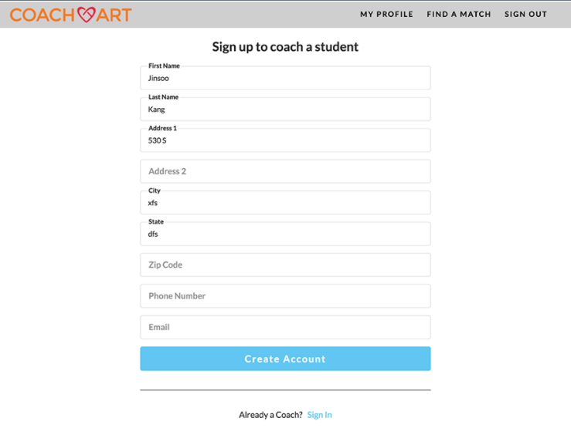

# New Match Student Design

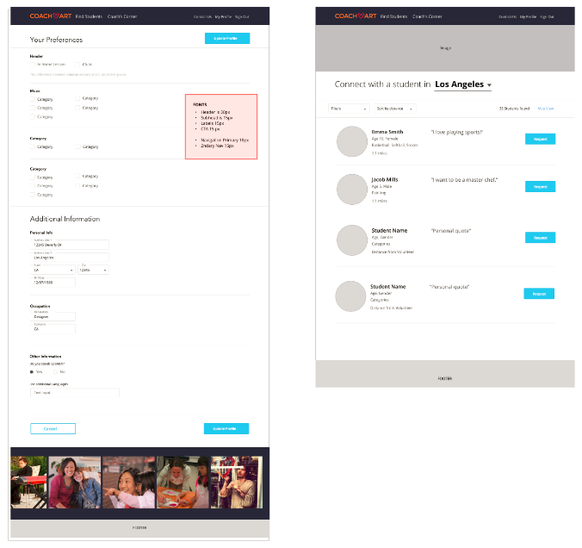

# Miscellaneous

### Current Examples of Volunteer Profile Page

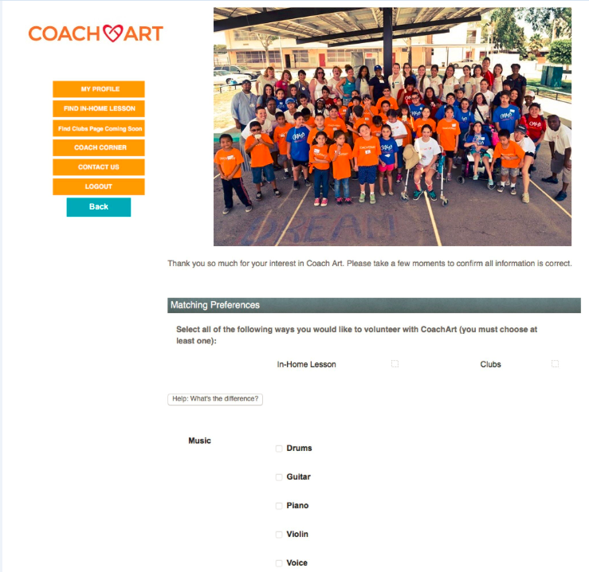











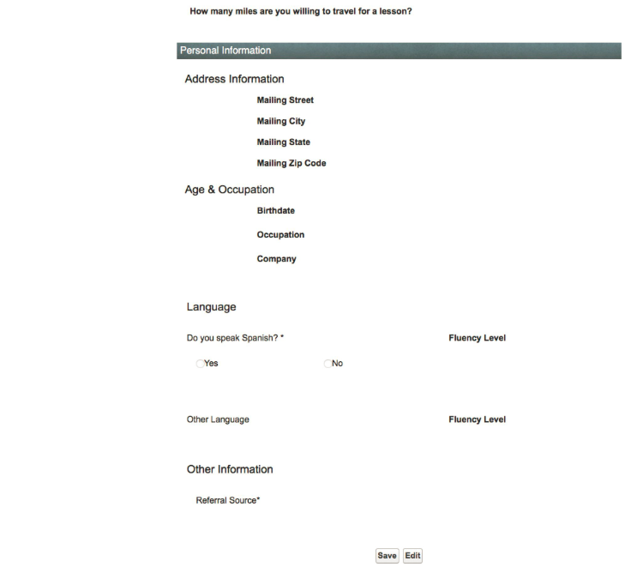

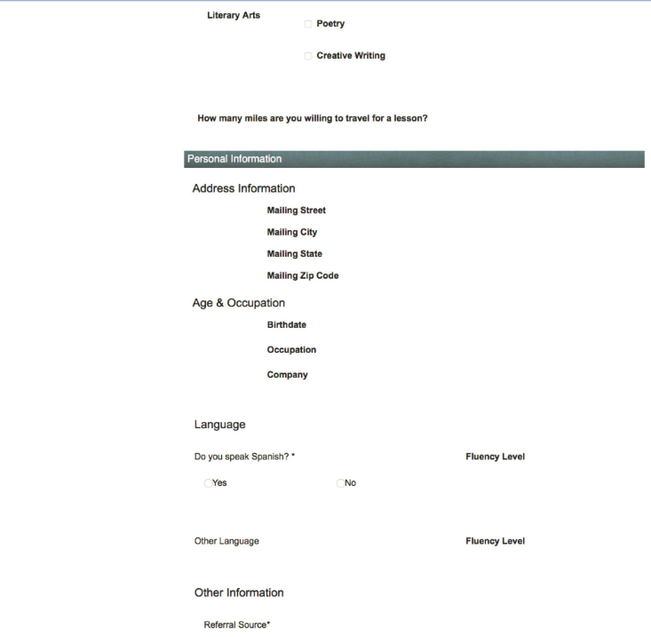



## Current MAP Design

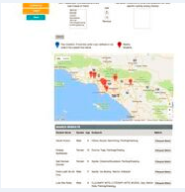

# Future considerations

* Facebook login
* Google Login
* Single Signon